

GIS Coursework

CS3210

Household waste dumping site selection

Damon Tran

Student Number: 160111190

**Background Research**

**GIS AND MULTI CRITERIA DECISION METHOD BASED APPROACH OF IDENTIFYING APPROPRIATE LANDFILL SITES FOR THE CITY OF CHITTAGONG ,**

1Department of Civil Engineering, Southern University Bangladesh, Chittagong- 4000, Bangladesh

2Department of Urban and Regional Planning, Chittagong University of Engineering and Technology, Chittagong- 4349, Bangladesh

3Department of Urban and Regional Planning, Chittagong University of Engineering and Technology, Chittagong- 4349, Bangladesh

***Received: 13 June Revised:10 July Accepted:9 February***

[1] Used GIS to tackle the problem of finding appropriate sites for solid waste landfills in densely populated areas. Taking into account the issues of disease, odour nuisance, atmospheric and water pollution that could affect the cities if landfill sites are not correctly chosen.

Through the use of geographic information system and a proposed method of multi criteria decision analysis with respect to environmental, economic and ecological factors they were able to choose effective landfill sites for disposing of solid waste.

Method of approach was by first surveying the area for relevant data that will enable them to select the sites. Creating several maps featuring water bodies, agricultural land, structures etc. [1] To create context and understanding of the area they are dealing with, as well creating various buffer zones around residential, commercial, agricultural areas to identify exactly where proposed landfill sites could be placed.(USING GIS)

After this MDC (multi-decision-criteria) analysis was used [1], whereby the landfill sites are chosen based on several pre-determined factors. For example climate, wind direction and soil condition, including the fact the council prohibited filling any area greater than 0.5 acres and 300 metres away from ponds to further filter out the number of possible landfill sites based on the criterion.

This research has proven to be positively impactful, as it has aided by giving valuable information which is given to the policy makers within Chittagong. Highlighting their need for re-evaluating waste disposal sites.

However, a weakness of this study is, that it requires further analysis of the soil type to identify whether these landfill sites are truly appropriate. As one test result is not enough to justify whether that landfill site meets the requirements that have been set based on the constraints.

Overall, this paper has been effective in identifying suitable landfill sites of the given study area by using GIS alongside with an MDC model, that ensures possible sites meet the criterion.

Koushik Paul, Amit Dutta & A.P. Krishna (2014) A comprehensive study on

landfill site selection for Kolkata City, India, Journal of the Air & Waste Management Association,

64:7, 846-861, DOI: 10.1080/10962247.2014.896834

Also bases its study of choosing landfill sites in a densely and highly populated city in India known as Kolkata. The main issues this paper tackles in trying to select such sites, is the effect that these landfill sites will have ecologically, environmentally and accessibility of its inhabitants much like [1] did, which imply that these factors are imperative when choosing landfill sites for cities.

By using the powerful tool GIS in conjunction with the government policy of solid waste management CPHEEO, there is a set of criteria that must be met when choosing landfill sites which are based on accessibility, receptor, environmental, socioeconomic,

waste management practices, and climatological and

geological criteria

[2] Uses GIS to create various different layers and maps for example, creating a map which displays vegetation, towns, water bodies and fallow land within the study area to create a composite layer from all of them to make easier visualisation and compare it to the possible landfill sites.

Afterwards they then looked deeper at the data within the maps they have created, mainly looking at the growth of population and projecting how far it will grow in a certain number of years in-conjunction with the rate of waste generation from the population to plan for the size of the area they can use for the landfill.

Many map layers made including wasteland, slope and elevation, forest, commercial areas etc. For the same reasons [1] did, to identify and separate specific areas and create buffers around them to find out where possible landfill sites can be chosen out of the proposed areas based on a set of criteria i.e. “no landfill site can be built within 20km of an airport”. Which is also known as spatial analysis [2].

And from the various maps created, with the given criteria the possible number of landfill areas are filtered out.

**APPLICATION OF GEOGRAPHIC INFORMATION SYSTEM AND REMOTESENSING**

**IN EFFECTIVE SOLID WASTE DISPOSAL SITES SELECTION IN WUKRO TOWN,**

**TIGRAY, ETHIOPIA** A.A., Mohammedshum,*a, M.A., Gebresilassiea, C.M., Rulindaa, G.H., Kahsaya, M.S., Tesfayb

This research makes it a standing point that waste dump selection is crucial to the development of an area, as well as preserving its environmental structure. This paper proposes by using GIS and Remote sensing, they were able to choose appropriate landfill sites. Based on a Multi-Criteria-Evaluation (MCE) method similar to [1] and [2]’s MCD criteria and sensitivity index methods respectively.

By using GIS the researchers were able to create various maps and layers consisting of important data which they then analysed based on their MCE method which took into account distance from centre of town and wind direction [3] for identifying and choosing various appropriate landfill sites which met the criteria that have been set.

Similarity between this paper and [1] and [2] is that they all survey the study area to create various thematic maps, which consist of important data that they need to take into account, when choosing a landfill site. By creating various map layers, they can analyse them and create composite layers such as buffer layers around certain map layers such as roads, agricultural land etc. to filter down possible landfill sites.

In addition it takes into account population growth and the size of waste generation produced from the growing population much like [2] did based on a statistical analysis of populated areas, and rate of growth using data and map layers from the past of the study area.

This paper based its site selection of landfill areas using a hierarchical decision model, which takes into account different categories and the various factors that could affect those categories which each have a rank and a weighting. Where lowest rank indicates that it is least suitable, and high indicates most suitable.

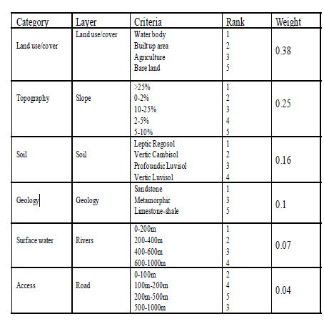

**APPLICATION OF GIS BASED MODEL IN LANDFILL SITE SELECTION: A CASE STUDY OF LAHORE, PAKISTANBYLINE:** S. Rathore, S.R. Ahmad and S.A. Shirazi, Pakistan Journal of Science

December 31, 2015 Thursday

This paper proposes selection of landfill sites, in Lahore based on processing and analysing spatial information obtained by using GIS to create various and relevant map layers.

Creating raster layers such as water bodies, roads, “important places” and existing dumping sites [4]. Which has been done in all research papers aforementioned.

The paper similarly to all the others makes an important note of how densely populated the study area as, as well as the positive correlation between increasing population and waste generation.

Additionally, much like the other papers bases its site selection from the analysis of the various map layers created and a set of constraints which take into account economic and environmental factors. Such as, sites are not able to be more than 300 meters in proximity to roads achieved through the use of buffer zones.

This paper proposes a criteria index which uses a formula for deciding a suitability value of a site based on the constraints set using a Boolean restriction model [4] by only displaying suitable areas on the raster map as a 1 and non-suitable areas as 0 (blank space).

Conclusion of Background Research

All research papers address the problem of finding suitable landfill sites based on a set of constraints by using GIS, a powerful tool for creating various map layers allowing for analysis of data and gaining a better understanding of their given study areas which allow for them to identify the most efficient and effective (suitable) landfill site.

By using GIS and a pre-deterministic list or model of rules, they are able to find landfill sites that promote economical, ecological and societal development of the area.

Requirements:

Continuing from the conclusion of the background research. According to all the past studies and research discussed, their methods included creating base maps to create thematic layers which offer valuable information enabling for effective analysis.

This includes creating a topography and land coverage layer. Topography layer will consist of map features regarding roads, structures, motorways etc. As well as the land coverage map providing data including water bodies, forests, arable land, agriculture and such.

These map layers will form the foundation of this study as the base maps. By creating a composite map from these two layers, it allows for easier analysis to filter down possible landfill sites by looking at where the landfill is located. I.e. if a landfill is located next to a road, or water body it should be ruled out based on the constraint set keeping in mind it should be environmentally sound and avoid disruption to the scenery etc.

However, there are more maps to consider from the base maps generated as well as the data sets provided.

Firstly, extending from the topography and land coverage maps, it may be beneficial to create certain buffer layers from features within those maps using the default GIS raster maps. For example, buffer layers for water bodies or roads etc. By creating appropriate buffer maps, it allows for easier analysis and understanding of generally what landfill sites are most appropriate based on the constraint of being environmentally sound to ensure that landfill site is built beyond these specified buffer zones.

Additionally, there are various data sets that have been given to consider when choosing the landfill site. Many layers should be created from these and combined with others to derive very important data that will be crucial. One example is to re-class the land coverage layer and create a land-cost layer by replacing the values with arbitrary ones by way of justification i.e. pastures and scrubs set to 1, whereas residential areas or water set to 10. As building the landfill in these different areas bring about different levels of complications with an associative cost.

After this, combining the land-cost layer with the soil-type layer will produce a cost surface map which highlights areas that will be low-high cost to build landfills based on information from both maps. Due to the fact that various different soil types will also affect the level of cost of building a landfill, in this case sand will cost less than a built-up area for example.

It will also be useful to create negative-buffer layers around specific areas consisting of rare wild-life to ensure that the landfill chosen is not located within these exclusion zones, to preserve the scenery and minimise negative impact to the environment.

As well as this, there are various different layers that will be important to the analysis of this study including: Net Income Survey, Wind Speed, Days with Fog, Mean Sunshine Hours.

By using the Net Income survey map, it allows us to see the locations of the population throughout Leicester. Indicating general locations which should be avoided when choosing the landfill, attempting to disrupt the population as least as possible.

With the wind-speed layer, this information highlights the average annual wind speed within different locations. Using this map to reduce air pollution is possible if selection of landfill is not placed in areas with high annual wind speeds.

Including this, it is possible to preserve the beauty and nature of the environment further when choosing the landfill regarding Days with fog map which indicates the average number of days that are foggy in different locations. By analysing this map data, choosing the landfill to be in areas where it is most foggy will not dramatically affect the environment as well as it not disrupting the scenery very much.

Moreover, Mean Sunshine Hours map shows the average hours of sunshine of each location in the study area. Analysing this map, can enable choice of landfill to be placed in locations where the mean value is low therefore affecting the scenery as little as possible.

Using all these layers, it is possible to derive more data from combining certain layers together. For example, combining all the buffer layers into one single layer allows easier analysis and comparison to other maps? Or combining the mean number of hours map and minimum temperature map will give birth to a map that shows areas which tend to be colder which is good as hot temperatures will enhance the smell of the landfill and cause great air pollution. By combining these two layers it makes it easier to see which areas the least significant negative impact will have to build landfills by minimising air and scenery pollution.

Another potential requirement that could add value to the analysis is by using a form of classification model, or rule list. To filter out what sort of landfill locations should be more suitable than others which will aid creating the various different buffer layers. For example, in the background research [1] and [2] used sensitivity indexes and MCD to shape their maps by creating buffers of specific distances from water bodies and roads to ensure that their landfill choice does not negatively impact the environment and populace. Perhaps using a similar strategy to classify suitable landfills will provide for better results.

Conversely, perhaps adopting a similar approach to [3] by using a hierarchical model that gives weights to various different categories and calculates the weight of the potential landfill site based on what attributes it takes from each category i.e. type of soil can be weighted as 0.25, distance from water bodies = 0.35 etc. By doing this it allows for an objective analysis of which landfill is most suitable while keeping in mind the different factors it should uphold.

**Design and implementation**

The method used in Grass to answer this problem, was performing a survey analysis by studying the area via obtaining important and relevant map layers. This included creating ‘base’ maps which consisted of a topography layer which gave details regarding roads, structures, motorways etc. As well as the land-coverage map giving information such as water bodies, urban areas and the like.

These maps were then broken down and extended further into sub-set maps, buffer maps which were derived from features within the base maps (water) or available raster maps Grass has provided such as urban. This included creation of urban-buffer, water-buffer maps. In order to analyse and filter general areas where landfills could not be built via use of the r.buffer command within Grass, distances of buffers varied depending on the feature the buffer was applied to i.e. 300m for roads, 1km for water-bodies. Moreover, all the buffer layers created initially were combined into a single buffer layer by using the r.mapcalc command via if(isnull) to change tge vakyes to make it easier to analyse but also make it understandable exactly what positions were valid for the landfill.

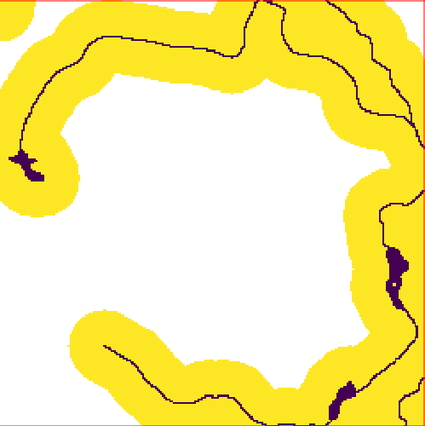

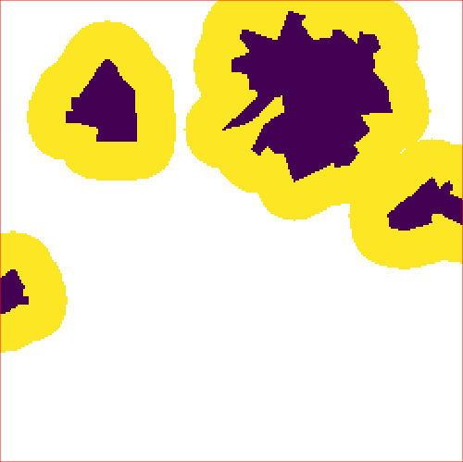Figure - Water buffer map (distance 1km)

Figure -Urban area buffer map (distance 300m)

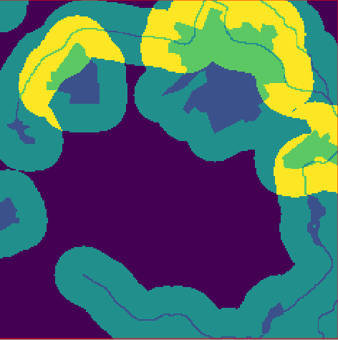

Figure - Combined buffer map layer from urban and water buffer maps

From the combination of both buffer maps, a spatial analysis makes it clear to see the general areas that the landfill should be built (in purple zones) to ensure that the landfill does not pollute nearby urban areas affecting the local people as well as contaminating the water bodies which was enabled by setting specific buffer ranges around these land coverage features.

After this, looking at a report of the landcov map, able to identify the various features within the map and reclass the map to produce a landcost map by changing the values with new ones.

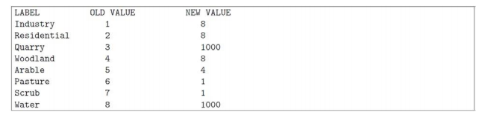Re-classifying the map to account for the level of cost which building a landfill in different types of areas would be.

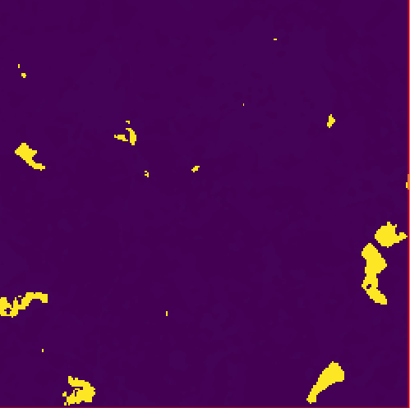

Figure -Land cost map showing low to high cost areas

Additionally, negative-buffer maps were created as exclusion zones around areas which consisted of rare wild-life including orchid trees, otters etc. To ensure landfill locations were not picked within these zones.



Figure -Exclusion zone of areas containing Otters (Yellow indicates areas landfill can be built)

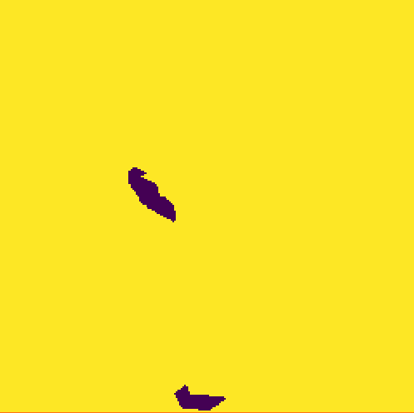

Figure - Exclusion zone of areas containing Skylarks (Yellow indicating areas landfill can be built)

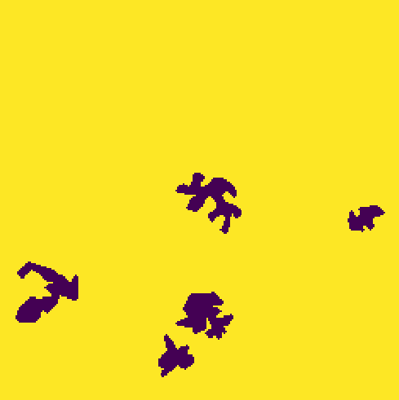

Figure -Exclusion zone of areas containing Orchids (Yellow indicating areas landfill can be built)

Looking at the data provided, there is rainfall data which shows the mean annual rainfall (in millimetres). in a given location. Unfortunately, it is only a small representation of the entire study area. Therefore, to determine the heaviest rain locations estimation through interpolation is required.

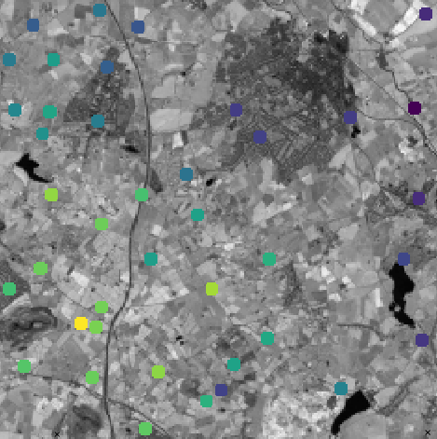

Figure - Map showing data points of annual rainfall in certain locations

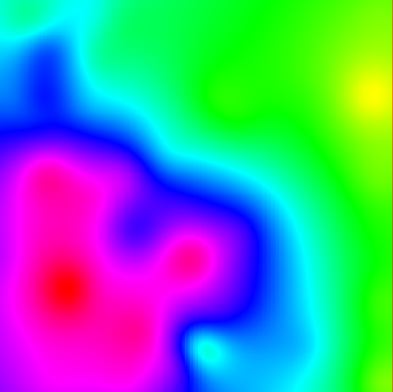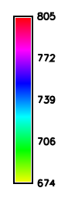

Figure - Map showing interpolation of rainfall data with legend indicating rainfall in areas (mm)

But initially, it is required to create a raster map representation of the vector layer using v.to.rast.

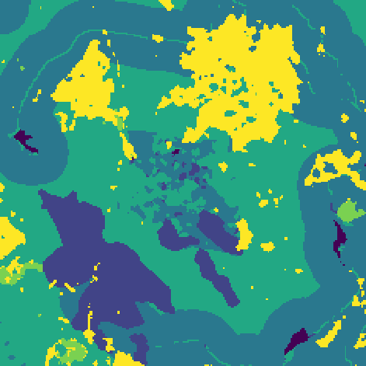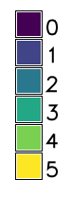

Looking at the soil map it indicates different features of soil type. 1 = sand, 2 = clay, 3 = loam, 4 = exposed rock, 5

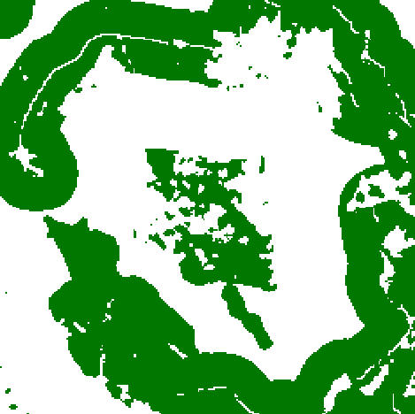

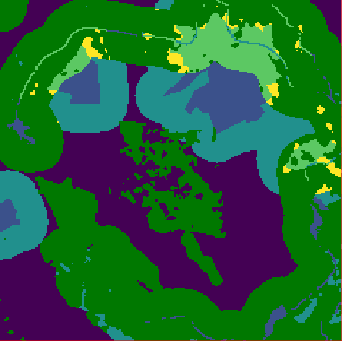

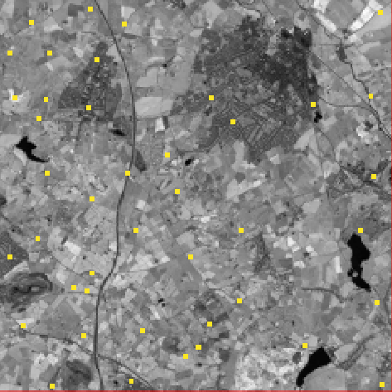

Buffer layers:

Waterbuffer

Roadbuffer

Urbanbuffer

All wildelife shit

Negative Buffer layers:

All of the wildlife shit

Combine these to get a single buffer layer:

if(isnull(mwaybuf),0,mwaybuf)+if(isnull(railbuf),0,railbuf)

Combine all negative buffers together.

Reclass Layers:

Landcov = landcost

Soil-type =soil-cost

Landcov= Grade3(Land that doesn’t cost much to tear up so anything from grass and shit to whatever)

Composite layers:

Landcost+soil type = cost-surface